SPEAKING ENGAGEMENT AGREEMENT
Page 1 of 2
Name of Company/Organization:
Address: Contact: E-Mail:
Business Phone: FAX:
Emergency Number:
Second Contact:
E-Mail:
Business Phone:
This LETTER OF AGREEMENT commits Francis Atta to present at the [Event Name] on [Event Date] from [Event Start and End Time].
Activity Location:
Presentation Theme and Time:
Activity Objectives: As a result of participating in this activity, learners will be able to:

HONORARIUM AND EXPENSES: The honorarium is to be determined.
Applicable expenses incurred for this activity will be billed immediately following completion of activity. Payment will be due within 7 days after receipt of invoice.
AUDIO AND VIDEO RECORDING:
Francis Atta will permit audio and video recording of this event and retains the right to make an audio or video recording of the event for brand development and educational purposes. Francis Atta may edit such recordings, as it deems appropriate, in its sole discretion. Francis Atta and [organization name] may use, reproduce and distribute the resulting work, in whole or in part, with or without charge, in any medium (including print and electronic media).
PRESENTATION REQUIREMENTS:
My presentation will include the following.
_____ PowerPoint Presentation ______VHS _____ CD _____ Other
_____ with embedded video
I require the following equipment.
_____ Computer & Projector _____ Internet Connection _____ VCR and Monitor flipchart
_____ Pointer _____ Microphone _____ Podium _____ Lavaliere _____ Wireless
Handouts:
_____ Please create handouts from the PowerPoint presentation
Handout Title:
_____ No handouts for distribution.

Room Setup
Page 2 of 2
Please indicate how the room will be setup.
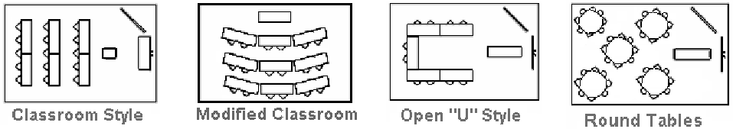
DRESS CODE
Casual Business Casual Formal Black Tie Other
LUNCH/DINNER/REFRESHMENTS
Will lunch/dinner/refreshments be served?
Yes No
AUDIENCE & SPECIAL GUESTS
Number of attendees Age group Male/Female/Both
Will there be any special guests (celebrities, dignitaries, community leaders, sponsors or associates)
Yes No
Please specify any audience details
PUBLICITY & PROMOTION
Will there be any publicity of this event? Yes No
How will the event be promoted? Website Social Media Flyers Advertising
Will a professional photographer be on site? Yes No
Please specify publicity and promotion details
GUESTS
How many guests can accompany Francis Atta? guests
ACTIVITY CANCELLATION:
Francis Atta reserves the right to cancel this activity at any time should illness or some other emergency arise, without penalty.
If activity is cancelled by the organization for any reason, any above mentioned honorarium will still be due to cover time spent preparing the speech, workshop or presentation.
Please return one signed copy of this agreement within two weeks of the agreement date, confirming that you have read, and will comply, with the statements made in this document.
The above is agreed to and accepted by:
Contact Signature: Contact Name:
Date:
Please submit completed agreement to: Mr. Francis Atta, 278 Cook Road, Toronto, ON M3J 0C6 or email form to Francis and Helen. attafr@gmail.com, (647) 408-2882, Helen Ojo, Publicist, helenojo03@gmail.com, (647)213-0183

